Name:………………………………………………..…. Date:………………………………………………………
Future Fuels
What car will you be driving in ten years' time? The chances are that the cars of the future will be quite different to those around now. Find out about how changes to fuel supply will affect car design and how designers, scientists and technologists are planning to fuel the future.

Collision course - which car?
Here is a newspaper report which describes key issues about cars of the future.
Read the report and answer the questions in the right hand column. Use Key words and Did You Know? About the greenhouse effect to help.

Minister is set for collision on move
to hydrogen cars
by Ben Webster, Transport Correspondent
used with kind permission of The Times Newspapers
The UK Government is facing a battle with leading car makers over the car of the future after deciding that fossil fuels will not be phased out for at least another 50 years.  Government ministers will not insist that Britain's cars convert to hydrogen by 2025. They called on car makers to develop more efficient petrol or diesel models. Instead, some car makers, including BMW, have invested hundreds of millions of pounds in developing emission-free cars that run on hydrogen.  Environmental groups say that a quick switch to hydrogen is vital if Britain is to reduce the production of carbon dioxide, the main greenhouse gas. Road transport accounts for 22 per cent of Britain's greenhouse gas emissions.  The Royal Commission on Environmental Pollution wants a 60 per cent reduction in Britain's carbon emissions by 2050. The Carbon Trust, a government-funded body supporting low-carbon technology, has told ministers that to meet this target hydrogen must be widely used to power cars by 2025.  But the Minister for Transport, Local Government and the Regions, said that BMW had ignored the energy savings of hybrid vehicles, which have an electric motor and a petrol engine. Hybrid vehicles made by Toyota and Honda are on sale.  The Minister said that renewable sources of hydrogen would not be available on a large enough scale for road transport until after 2050. He is therefore refusing to support a national network of hydrogen filling stations. | - What are fossil fuels?  - Why do people think these fuels should be 'phased out'?  - What does the government mean by 'more efficient' petrol or diesel cars?  - Why is hydrogen an 'emission-free' fuel?  - Why is it important to reduce carbon dioxide production?  - What is 'low-carbon technology'?  - How would using hydrogen-fuelled cars help reduce carbon emissions?  - What is a 'hybrid' vehicle?  - What does the Minister mean by a 'renewable' source of hydrogen?

continued on next page



Future Fuels
continued from previous page

The Minister tried a Toyota Prius, a hybrid car, for a weekend and said he was very impressed by its fuel efficiency. 'I was getting just under 60 miles to the gallon. Similar cars would be lucky to get 35.' A Toyota Prius costs £16,000, about £4,000 more than a conventional car of a similar size.  BMW's chairman, criticised hybrid cars as a compromise, saying: 'Hybrid engines only shift the burden of emissions. We don't think they are an important alternative.' He added that motorists would have to pay more for the hydrogen-powered BMW 7 series.  A leading car industry expert from Cardiff University said that using hybrid vehicles would slow the move to hydrogen. He added: 'A hybrid car is 15 to 20 per cent more expensive than a vehicle with one engine. People want to be environmentally responsible but they can't afford to be.'  Prototypes of BMW's hydrogen-powered 7-series have driven 100,000 miles without problems. The engine can run on hydrogen and petrol, so cars could be driven before a network of hydrogen filling stations exists. BP will open Britain's first such station in London next year, when a small number of hydrogen-powered buses will be introduced.  The Minister agreed that hybrid vehicles would always be more expensive than petrol-only cars, but he said that they offered the best chance of an early reduction of greenhouse gas emissions.  © The Times, 22nd April 2002  (Photocopying allowed for classroom use only) | - Why does the Minister think having a renewable source of the gas is needed?  - What is meant by 'fuel efficiency'? Why is this important?  - Why does the BMW chairman disagree with the Minister's views on hybrid cars?  - Why does the car industry expert disagree with the Minister's views on hybrid cars?  - Why is it useful to have a car which can run on hydrogen or petrol?

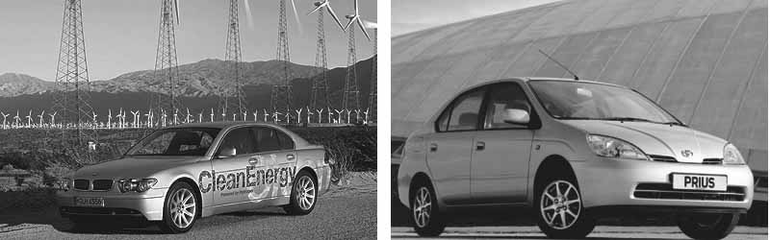

BMW Clean Energy - the hydrogen powered car  Reproduced with kind permission from Rosemary Davies, BMW. | The Toyota Prius - a hybrid car  Reproduced with kind permission from Samantha Williams, Toyota Press Office.

